Introductory Practical:
Investigating how the resistance of a wire varies with its length

Learning objectives:

After completing the practical you should be able to:
- Use a ruler to measure the length of a wire and determine the uncertainty in your measurement.
- Use a multimeter in its ohm-meter setting to measure the resistance of a wire and determine the uncertainty in your measurement.
- Record your data in an appropriate table.
- Plot an appropriate graph of your data.
- Extension activity: Use a micrometer to measure the diameter of a wire and hence determine the cross-sectional area of the wire and determine the uncertainty in this.

Background information:

The resistance, R, of a wire (or any object with a uniform cross-sectional area) is proportional to the length of the wire, L, so we can write R ∝L.

Therefore, R = kL where k is the constant of proportionality.

In this practical you will be testing this relationship. You will be using a multimeter in its ohm-meter setting to measure the resistance of a wire and plot a graph of your results.

After carrying out your readings, you will plot a graph of resistance against length for your wire. You will then be able to use this graph to find the value of the constant k.

You will also be finding the cross-sectional area of the wire you are using for the practical. The area of a circle is given by the equation Area = πr².

Equipment and materials:

a length of wire
a metre rule
a micrometer
a multimeter
connecting wires
crocodile clips
2 strips of stiff copper

Method:
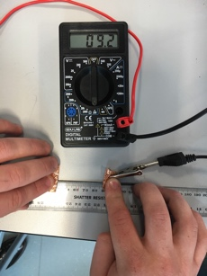
- Decide upon a sensible range of lengths of wire on which to carry out your measurements.
(Do not use a starting length shorter than 10 cm). Use Results Table 1 below to record your results.
- Ensure that your multimeter is set to the ohm-meter function.
- Connect the crocodile clips to the strips of copper and press these down firmly on wire so the distance between their inside edges is the distance you want for your first reading.
- Take your ohm-meter reading and record it in the table.
- Repeat steps 3 and 4 for each of your chosen lengths of wire.

Results Table 1:

Length / m | Resistance / Ω

Results Table 2 (for extension activity):

 | Diameter of wire / mm
1 | Diameter 1: _______  Diameter 2: _______  Average: _______
2 | Diameter 1: _______  Diameter 2: _______  Average: _______
3 | Diameter 1: _______  Diameter 2: _______  Average: _______

Average Diameter: ____________

(do not include any anomalous results)

Uncertainties:

The smallest uncertainty in measuring a quantity with a particular instrument is:
+/- (plus or minus) half the value of the smallest division of the reading on the instrument.

Remember that, when measuring the length of something using a ruler, there are sometimes two uncertainties because there is an uncertainty at each end at which you are taking a reading.

Percentage uncertainty in a measurement is given by:

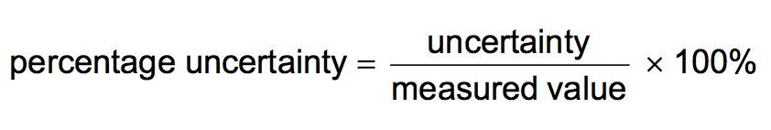

When quantities are multiplied or divided, the total percentage uncertainty is the sum of the percentage uncertainties.

When a quantity is raised to the power n, the total percentage uncertainty is n multiplied by the percentage uncertainty. E.g., for a quantity x², total percentage uncertainty = 2 × percentage uncertainty in x.

Questions:

What is the uncertainty in your length measurements? ______________

What is the percentage uncertainty in your shortest length measurement? ______________

What is the percentage uncertainty in your longest length measurement? ______________

What is the uncertainty in your resistance measurements? ______________

What is the percentage uncertainty in your smallest resistance measurement? ______________

What is the percentage uncertainty in your biggest resistance measurement? ______________

Graph:

The relationship between the resistance of a wire and its length is given by R = kL, which is of the form y = mx + c, where m is the gradient of the graph and c is the y-intercept.

Plot a graph of resistance against length, remembering to label your axes and use an appropriate scale. Carefully draw a line of best fit through your points.

Calculate the gradient of your graph by drawing a large triangle and show the values you are reading from the graph.

What is the value of k for your wire? _________.

What are the units of k? _________.

Extension activity:
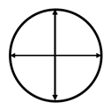
Use a micrometer to measure the diameter of the wire you have used, at 3 different points along the wire. At each point, you must take two readings at right angles to each other.

Complete Results Table 2 for this, so that you can later calculate the average cross-sectional area of the wire and determine the uncertainty in this.

Note: If you take a range of readings for a measurement, the uncertainty is given by half the range, that is given by: uncertainty = ½ × range = ½ (max. value – min. value)
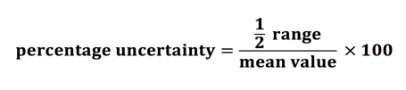
The percentage uncertainty in this case is given by:

What is the cross-sectional area of your wire? _________________

Why did you have to take readings of the diameter at three different places along the wire?

________________________________________________________________________________

At each point, why did you have to take two readings of the diameter at right angles to each other?

________________________________________________________________________________

What is the uncertainty in your diameter measurements? ______________

What is the percentage uncertainty in your diameter measurements? ______________

What is the percentage uncertainty in your value for the cross-sectional area of the wire? ______________

